Earth and Space Science Institute (ESSI) Strategy 2026–2030

Executive Summary
The Kingdom is undergoing an unprecedented national transformation, where space technologies, geospatial intelligence, and satellite imagery are rapidly becoming foundational pillars for national security, economic competitiveness, and evidence‑based decision‑making. Within this context, the Earth & Space Science Institute (IESS) emerges—after a 40‑year track record of scientific achievement—as a sovereign enabler for building a national space ecosystem driven by research, development, and innovation. This strategy aligns with KACST 2030 directions and positions the Institute to evolve from a traditional research center into a national platform for high‑precision geospatial data, advanced space technologies, and innovation‑led production

Earth and Space Science Institute (ESSI), leveraging over 40 years of foundational excellence. The prevailing Research-Based paradigm, characterized by stand-alone scientific publications and isolated pilot projects, must be structurally replaced by an Impact-and-Commercialization Operational Model.

This strategy transitions IESS into an agile, asset-backed commercial enabler feeding directly into Future Economies sector. By transforming its core capability tracks into specialized, high-revenue National Laboratories, IESS will monetize a 40-year satellite imagery archive, build secure autonomous geospatial data layers, and deploy deep-space surveillance assets. The objective is to achieve financial self-sustainability, localize cutting-edge dual-use space technologies, and position the Kingdom as the dominant regional hub for space-based independent infrastructure.

Why now?
Because the space economy exceeds $600 billion and is heading toward a trillion; because relying on global data providers is no longer acceptable given security challenges; and because national transformation projects—from NEOM to mining and energy—depend on accurate space-derived data. The Kingdom now has the infrastructure, sovereign support, and government demand that make this moment ideal to launch.
Economic return:
Launch commercial products (Imagery API, InSAR Dashboard, HD Maps, Digital Twins, SSA Engine), establish 6 spin-off companies, and achieve revenues of SAR 200–250 million by 2030, in addition to reducing spending on foreign data providers and creating high-quality jobs in the space economy.
Security return:
Cover 100% of Saudi space situational awareness (SSA), provide early warning for natural disasters, monitor borders and critical facilities, and secure sensitive data through national data layers produced and analyzed within the Kingdom.
Scientific return:
A 40-year national archive, national research platforms (GeoAI, Digital Twins, Research API), training for 200 Saudi researchers and engineers, and the generation of 40 patents/applied research outputs.
What sets IESS apart?
Ownership of space and geospatial infrastructure, the ability to produce and analyze data locally, its location within KACST, an integrated lab model (NEOL – NGSL – NAOL), and its capacity to turn scientific research into commercial exportable products.

Vision
To pioneer the regional future economies driven by advanced Earth and Space Science technologies.

Mission
To be the definitive contributor to research, development, and industrial localization that drives the Kingdom’s leadership in space. We transform academic ideas into high-margin commercial solutions, localizing advanced space technology and supporting local content.

Strategic Objectives
1. Transition to an Impact and Commercialization Operating Model | Structurally replace the legacy research-only model with specialized, revenue-generating National Laboratories.
2. Maximize and Monetize Data Assets | Turn long-term geospatial archives and automated satellite data feeds into high-margin subscription APIs and early awareness platforms.
3. Localize Strategic Dual-Use Technologies | Build domestic industrial capacities for small-satellite manufacturing, inertial navigation systems, and sovereign space communication systems.  The objective includes launching the Saudi Space Localization Accelerator (SSLA) program in phases:  • Knowledge transfer  • Building production lines  • Training technicians  • Prototyping  • Quality certification
4. Adopt Public-Private Partnerships (PPP): | Attract private investments and international space-tech funding through joint venture shared laboratories and data-for-equity frameworks.
5. Build a High-Tier Space Science Cadre | Establish deep technical talent pipelines in artificial intelligence, non-terrestrial cloud architecture, and space sciences through applied academic innovation hubs.

Comprehensive Multi-Agency Strategic Alignment Matrix
To unlock national funding channels, avoid wasteful asset duplication, and firmly secure institutional buy-in, IESS goals must align precisely with the mandates of key civil, military, and regulatory stakeholders.

Stakeholder / Agency | Core Priority/Need Aligned with IESS | Specific Interoperability & Strategic Action Mechanisms
Saudi Vision 2030 | Non-oil GDP diversification; expansion of local content; fostering of tech-driven startups. | Map downstream services into high-margin commercial data APIs; build incubator pipelines for domestic Space-Tech spin-offs.
Research, Development, & Innovation Authority (RDIA) | National RDI Mission Charters (Sustainability, Economies of the Future). | Execute Wave 1 space missions under institutional co-funding frameworks; secure programmatic grants for applied technological developments.
Ministry of Environment, Water and Agriculture (MEWA) & Environmental Centers | National Environment Strategy execution; climate forecasting, wildlife tracking, automated pollution tracing, and landfill tracking. | Ingest multi-sensor arrays (SAR, InSAR, Hyperspectral) into automated pipelines to audit the Saudi Green Initiative, monitor aquifers, trace spills, and map weather events.
Saudi Space Agency (SAA) | Operational execution of the National Space Strategy; deep-space exploration and lunar/Mars positioning. | Act as the primary technical execution arm for upstream satellite assembly, integration, and testing (AIT), alongside uncrewed rover research.
Saudi Geological Survey (SGS) | National mineral mapping, asset exploration, and sustainable mine safety. | Supply systematic Synthetic Aperture Radar (SAR) and Interferometric SAR (InSAR) surface deformation models for structural stability assessments.
General Authority for Survey & Geospatial Information (GEOSA) | National governance of spatial data, reference stations, and geodetic positioning. | Provide GEOSA with hyper-precise ground acquisition baselines and serve as an automated processing node for the national spatial data infrastructure.
Ministry of Municipalities & Housing (MOMAH) | Smart city expansion, urban landscape upgrades, and real-time municipal planning. | Deliver continuous urban vegetation mapping and predictive AI heat-island modeling to lower city surface temperatures.
Ministry of Defense (MoD) & General Authority for Military Industries (GAMI) | Military-grade spatial reconnaissance, localized defense supply chains, and secure communications. | Co-develop autonomous dual-use Earth Observation (EO) sensors and deploy encrypted Low Earth Orbit (LEO) satellite communication constellations.
Communications, Space & Technology Commission (CST) | Telecommunications regulation, satellite licensing, spectrum oversight, and NTN architectures. | Run validation testbeds for emerging Terrestrial and Non-Terrestrial Network (TN/NTN) communication protocols.
Ministry of Energy (MoE) | Infrastructure protection, pipeline failure detection, and renewable energy integration. | Provide autonomous, automated thermal and short-wave infrared (SWIR) satellite surveillance across the Kingdom's vast energy transmission networks.
Universities & National Research Centers | Academic development, specialized research talent pipelines, and scientific publication output. | Maintain open, low-cost distributed regional networks of radio telescopes to power collaborative planetary science and aerospace engineering programs.

Core Pillar Strategy: Transitioning to Specialized National Laboratories
IESS will structure its capabilities into three distinct, impact-focused National Laboratories powered by Artificial Intelligence (AI) and emerging technologies.

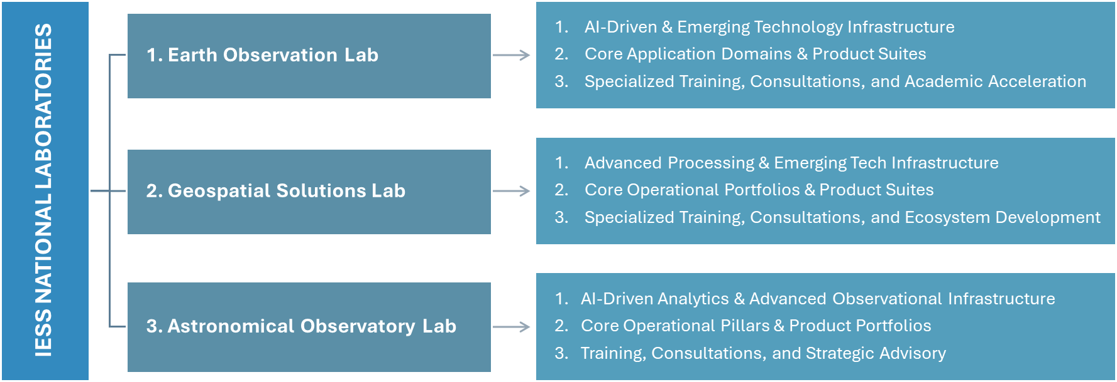
The three national laboratories—NEOL, NGSL, and NAOL—will transition from traditional cost centers into revenue‑generating national assets. In alignment with KACST’s mandate to maximize the value of laboratories and infrastructure, the Institute will adopt a commercial operating model built on paid operations, subscription‑based access to geospatial platforms, specialized consulting services, and long‑term government service contracts. This shift positions the laboratories as strategic economic engines supporting national sovereignty and the emerging space‑data economy.

Pillar 1: The National Earth Observation Laboratory (NEOL)
Building on the strategic transition from a traditional research model to an impact-driven architecture, the National Earth Observation Laboratory (NEOL) will be structured to serve as a premier autonomous intelligence and predictive analytics hub.
By embedding artificial intelligence, computer vision, and big data architectures directly into the satellite data lifecycle, NEOL will convert raw imagery into high-margin, actionable downstream products, specialized training modules, and strategic consultations for national beneficiaries.
• Strategic Imperative
Transition from passive data gathering to an active, predictive analytics ecosystem that services defense, environmental, and infrastructure stakeholders.
• AI-Driven & Emerging Tech Capabilities
Deploy deep learning architectures (Convolutional Neural Networks and Vision Transformers) directly onto multi-modal sensor streams. Melt distinct tracking capabilities, fusing Electro-Optical (EO), Infrared (IR), Hyperspectral, and Synthetic Aperture Radar (SAR), into unified, real-time tracking pipelines.
• Monetization & Products
Imagery API | Early Awareness System
Commercialize the institute’s unique, continuous 40-year satellite archive via a subscription API tailored for urban development historical analyses and legal property boundary assessments | Sell real-time anomaly detection pipelines to civil defense and municipal authorities for early detection of flash floods, active sandstorms, structural pipeline compromises, or industrial carbon emission spikes

1. AI-Driven & Emerging Technology Infrastructure
To move past manual image analysis, NEOL will deploy an integrated, cloud-native computational pipeline capable of processing massive volumes of multi-modal data automatically.
• Computer Vision and Deep Learning Foundation:
Utilizing deep neural networks (such as custom-trained Vision Transformers and convolutional architectures) to execute automated object detection, multi-class semantic segmentation, and instant feature extraction at scale.
• Multi-Modal Data Fusion
Fusing disparate sensor streams—combining high-resolution Electro-Optical (EO) crispness, Thermal/Infrared (IR) signatures, Hyperspectral chemical footprints, and day/night Synthetic Aperture Radar (SAR) waveforms—into a single, consolidated operational dashboard.
• Automated InSAR and Deformation Stacks
Deploying continuous, automated Interferometric SAR (InSAR) processing loops to solve for millimeter-level surface displacement and vertical land deformation across the entire geography of the Kingdom without human intervention.

2. Core Application Domains & Product Suites
NEOL will align its technical outputs with distinct commercial product suites to satisfy the operational needs of national civil, defense, and industrial partners.
A. National Security & Tactical Reconnaissance
• Independent Border Surveillance
Autonomous computer vision pipelines trained to run anomaly and change detection across strategic land borders and maritime corridors, automatically flagging un-flagged structural assets or vehicles.
• Strategic Foreign Asset Monitoring
Supplying localized intelligence agencies with custom, high-accuracy tasking capabilities to observe and map global developments relevant to Saudi Arabia's defense interests.
• Military Mobility Maps
Fusing optical and SAR datasets to deliver dynamic terrain trafficability mapping, soil moisture composition metrics, and precise tactical navigation base-layers.
B. Smart Cities & Urban Twins
• Dynamic Urban Landscape Tracking
Delivering continuous, automated spatial data directly to entities like MOMAH and NEOM to monitor physical construction velocities, structural vertical alignment, and zoning compliance.
• Predictive Urban Heat-Island Modeling
Leveraging thermal infrared sensor channels to generate surface temperature trends, allowing municipal planners to optimize green infrastructure layouts and achieve the target of reducing summer surface temperatures by 4°C.
• Infrastructure Health Alerts
Automated alerts for critical national infrastructure via InSAR, identifying subtle pavement cracking, structural bridge shifting, or airport runway sinking before failure occurs.
C. Environmental Monitoring & Climate Sustainability
• The Saudi Green Initiative Engine
Serving as the definitive auditing node for the "Plant 10Bn Trees by 2040" mission by utilizing hyperspectral data to verify precise plant counts, evaluate crop health parameters, and measure localized carbon sequestration densities.
• Early Warning Disaster Infrastructure
Deploying proactive predictive models to mitigate risks from flash flooding, dynamic sandstorm propagation, and active wildfire spread, feeding directly into local early warning systems.
• Aquifer & Marine Ecosystem Auditing
Monitoring surface deformation variables to evaluate groundwater extraction impacts and sustainable aquifer capacity, alongside tracking coastal oil spills and coral reef health.
D. Energy & Mining Logistics
• Pipeline Integrity Monitoring
Drone and micro-satellite sensor loops scanning vast oil and gas transport segments to catch un-mapped leakages, structural ground shifts, or vegetation encroachment risks.
• Automated Mineral Exploration Support
Producing hyperspectral background imagery and geological baseline vectors to map mineral surface expressions and optimize mineral extraction programs.

3. Specialized Training, Consultations, and Academic Acceleration
To cultivate a sustainable local space sector ecosystem, NEOL will operate a dedicated, revenue-generating knowledge transfer and advisory division.
A. Professional Training & Certification Programs
• Applied Space-Data Engineering Academy
Offering multi-tiered professional certificates for remote sensing analysts, focusing on cloud architecture execution, scalable geospatial data engineering, and machine learning deployment.
• AI-Driven Remote Sensing Bootcamps
Direct training tracks tailored for data scientists within external ministries (e.g., Ministry of Defense, Ministry of Energy) to build custom domain-specific segmentation models.
B. Strategic Consulting and Advisory Services
• Feasibility Studies and Mission Architecture Design
Acting as the primary state technical consultant to evaluate sensor payloads, orbital configurations, and downstream pipelines for any independent entity or private enterprise deploying space assets.
• National Standards Governance
Collaborating with regulatory bodies to define and maintain unified national metadata standards, precision criteria, and security classification levels for all earth observation activities.
C. Academic Co-Innovation Hubs
• Distributed Open-Data Repositories
Launching a secure sandbox environment that provides national universities with access to indexed, clean satellite data subsets, accelerating the publication of peer-reviewed scientific studies and national patents.
• Joint PhD and Post-Doc Fellowships
Sponsoring applied research theses centered on cutting-edge space problems to systematically build the domestic research cadre.

Pillar 2: The National Geospatial Solutions Laboratory (NGSL)
To complement the transformation of our Earth Observation capabilities, the National Geospatial Solutions Laboratory (NGSL) will serve as the engine room for the Kingdom's spatial data infrastructure. The primary focus of this national laboratory is to transition the institute from flat, static mapping into a provider of dynamic, multi-dimensional geospatial intelligence.
By modernizing our 40-year heritage in GIS, geodesy, and high-precision positioning, NGSL will leverage artificial intelligence, edge computing, and advanced spatial modeling to deliver premium downstream products, corporate certifications, and strategic spatial consultations.
• Strategic Imperative
Serve as the prime national repository and intelligence processing engine for geodetic reference networks and spatial lifecycle management.
• AI-Driven & Emerging Tech Capabilities
Utilize point-cloud segmentation models, automated edge computing, and neural rendering to process high-precision ground acquisitions and automated drone surveys into dynamic models.
• Monetization & Products:
Dynamic Kingdom Digital Twins | Mobility Base-Layers
Provide continuous, high-resolution 3D geospatial vectors to builders of mega-projects (such as NEOM and Red Sea) to monitor physical development speeds, volumetric land excavations, and precise structural settling parameters. | Generate high-definition (HD) localization mapping layouts to support next-generation commercial autonomous vehicle fleets, logistics routing systems, and delivery drone paths across urban centers.

1. Advanced Processing & Emerging Tech Infrastructure
To meet the complex tracking needs of massive regional developments, NGSL's computing environment will focus on automating data extraction, lifecycle orchestration, and spatial geometry modeling.
• AI-Driven Automated Feature Extraction
Deploying neural networks trained on top-grade topographic imagery to automatically discover, classify, and extract geometric features (such as roads, structural building footprints, transmission lines, and water channels). This removes months of manual vector editing and accelerates map production cycles.
• Real-Time Spatial Data Streams & IoT Integration
Building high-throughput cloud ingestion loops to process active spatial telemetry from Internet of Things (IoT) sensors, mobile networks, and connected transport fleets.
• Next-Generation Cloud Geodesy
Utilizing advanced mathematical modeling and physics algorithms to automate the continuous adjustment of national coordinate reference frames, calculating precise tectonic shifts and structural baseline variations across the Arabian plate.

2. Core Operational Portfolios & Product Suites
NGSL will structure its technical capabilities into high-demand commercial product lines targeting distinct state and commercial target industries.
A. Dynamic City Digital Twins (3D & 4D GIS)
• Volumetric Development Auditing
Building spatial models that integrate traditional GIS with building information data (BIM) to track ongoing macro-construction progress, land excavation volumes, and raw material logistics.
• Subsurface Infrastructure Mapping
Creating secure 3D spatial registries mapping underground utilities, transport networks, and municipal pipelines to prevent collision risks during rapid infrastructure expansions.
B. Autonomous Transport & Mobility Base-Layers
• High-Definition (HD) Mapping Baselines
Supplying sub-decimeter accurate road geometry, lane-boundary vectors, and intersection layouts to empower autonomous automotive vehicles and intelligent transport systems.
• Micro-Mobility and Drone Airspace Routing
Designing low-altitude 3D corridors and dynamic spatial obstacles grids to govern urban cargo drone delivery networks safely.
C. Predictive Location Analytics & Strategic Insights
• Structural Health and Subsidence Alerts
Generating predictive geospatial risk maps identifying slow structural settling, bridge leaning, or terrain instability near high-value economic corridors.
• Intelligent Crowd Management Systems
Applying geospatial spatial-temporal modeling to predict traffic congestion points and coordinate crowd movements safely within smart city zones.
• Resource Optimization Infrastructure
Providing agricultural geospatial intelligence, asset visibility maps, and energy logistics distribution networks to optimize the performance of national resource portfolios.

3. Specialized Training, Consultations, and Ecosystem Development
To drive complete national localization and support domestic space-tech startups, the laboratory will operate a commercial spatial engineering and certification business unit.
A. Professional Training & Certification Programs
• Spatial Data Scientist Academy
Offering structured, multi-tier professional credentials covering spatial database architecture, automated Python-based spatial processing, and machine learning analytics.
• Smart City Spatial Integration Tracks
Specialized professional development training for municipal engineers and private defense contractors to implement advanced spatial data infrastructure standards.
B. Strategic Consulting and Spatial Advisory
• National Spatial Infrastructure Advisory:
Acting as the prime technical advisor to design, calibrate, and evaluate large-scale spatial databases and geodetic reference networks for state and private enterprises.
• Interoperability Standards Governance
Defining unified national geodatabase schemas and metadata criteria to guarantee fluid interoperability across national security and infrastructure stakeholders.
C. Academic Acceleration & Startup Sandboxes
• The Geodata Vault
Hosting an isolated, high-performance computing repository that exposes rich baseline geographic layers to national universities, fueling research in smart logistics, hydrology, and environmental geology.
• Venture Incubation Pipelines
Providing early-stage space-tech and mapping startups with access to high-accuracy geodetic processing software platforms to catalyze new geospatial consumer services.

Pillar 3: The National Astronomical Observatory Laboratory (NAOL)
To complete the strategic modernization of the institute, the National Astronomical Observatory Laboratory (NAOL) will be established to transform Saudi Arabia’s astronomical capabilities from traditional sky observation into an advanced, data-driven space science engine.
By upgrading our historical observatory networks with artificial intelligence, automated sensor arrays, and edge-computing optics, NAOL will secure oversight of our regional sky sector, streamline civil calendar calculations, and build a high-revenue ecosystem for astrophotography, astro-tourism, and deep-space research.
• Strategic Imperative
Establish a state-of-the-art observation capability to secure regional sky-sector supremacy and drive high-impact planetary and space tourism revenues.
• AI-Driven & Emerging Tech Capabilities
Apply automated computer vision algorithms to stellar sensor arrays for space situational tracking and coordinate real-time tracking arrays with automated multi-station telescopes.
• Monetization & Products:
Space Situational Awareness (SSA) Engine | Civil Calendar Validation Systems | Astro-Tourism & Stargazing Infrastructure
Provide defensive orbit tracking services to flag and avoid space debris collisions threatening valuable satellite assets | Serve as the absolute technical verification node for the Umm Al Qura calendar authority and national moon-sighting committees using high-altitude mid-day infrared crescent capture devices | Develop commercial dark-sky reserves and deep-space observatory installations in remote regions of western and northwestern Saudi Arabia, offering premium astro-educational platforms and tourist facilities

1. AI-Driven Analytics & Advanced Observational Infrastructure
To move beyond manual lens adjustments and localized data silos, NAOL will deploy a synchronized, software-defined network of robotic ground telescopes and space situational awareness (SSA) computing architectures.
• AI-Automated Transient Detection & Classification
Integrating machine learning computer vision models directly onto digital optical and radio telescope streams. These models will automatically identify, track, and categorize fast-moving astronomical events, such as near-Earth asteroids, supernovae, and orbital space debris, without requiring continuous human tracking.
• Robotic Autonomous Telescope Networks
Upgrading scattered regional observatories into an interconnected, self-orchestrating matrix. When an anomaly is discovered by one sensor, the centralized AI routing loop will automatically task adjacent telescopes to adjust their focus and lock onto the coordinates instantly.
• Space Situational Awareness (SSA) Engine
Deploying high-precision optical and radio wave tracking pipelines to map, monitor, and predict the trajectories of foreign satellites and orbital clutter passing through the Kingdom's airspace, directly supporting national asset protection.

2. Core Operational Pillars & Product Portfolios
NAOL will segment its technical operations into commercial and civic product lines designed to service government, industrial, and public stakeholders.
A. Civic Calendar Verification & Islamic Astronomy
• Automated Lunar Month Verification APIs
Partnering directly with the Umm Al Qura calendar authority and national moon-sighting committees. NAOL will utilize unique, high-altitude mid-day infrared and crescent telescope setups to automatically capture, enhance, and digitally verify the birth of the lunar crescent through a secure, auditable data stream.
• Precision Astronomic Reference Datasets
Serving as the Kingdom's absolute astronomical calculation authority to generate bulletproof geographic coordinates for prayer times, exact Qibla vector alignments, and global Islamic solar/lunar eclipse maps.
B. Deep-Space Research & Planetary Exploration Support
• Space Flight and Rover Simulation Environments
Providing advanced astrophysical modeling, space radiation assessments, and planetary atmospheric interaction simulations to evaluate hardware designs for upcoming lunar and Mars surface rovers.
• Distributed Radio Astronomy Frameworks
Setting up a wide-baseline network of low-cost radio telescopes across national universities to conduct structural research on binary stars, deep-space pulsars, and galactic emission frequencies.
C. Public Astro-Economy: Education & Tourism
• Dark-Sky Reserve Designations
Providing specialized spatial consulting to mega-projects (such as NEOM, AlUla, and The Red Sea) to secure international dark-sky certifications, protecting the environment while creating prime geographic footprints for stargazing.
• Immersive Astro-Tourism Products
Developing turn-key observatory experiences, cloud-linked amateur astrophotography stations, and automated stargazing applications tailored to luxury eco-tourism resorts.
• Mobile Observatory Educational Fleets
Deploying a fleet of connected, vehicle-mounted mobile educational observatories equipped with digital smart telescopes and virtual reality space simulators to cultivate the next generation of space scientists across regional schools.

3. Training, Consultations, and Strategic Advisory
To establish the country as the definitive regional astronomical authority, NAOL will operate a commercial knowledge transfer and engineering advisory wing.
A. Professional Training & Community Development
• Space Sciences & Analytics Academy
Offering rigorous professional training programs centered on space data processing, deep-space telemetry analysis, and radio signal engineering.
• Astro-Tourism Operational Certification
Providing formal training and qualification tracks for local tour guides and hospitality operators to specialize in dark-sky management, telescope operations, and night-sky storytelling.
B. Strategic Astronomical Consulting
• Telescope Architecture Advisory
Serving as the state's prime technical consultant to inspect, engineer, calibrate, and repair precision optical systems, custom lens tracking rigs, and high-altitude observatory assets for public and private enterprises.
• Astrophysical Risk Mitigation Studies
Providing custom advisory reports assessing solar radiation storms, space weather threats, and cosmic ray impacts to safeguard commercial satellite infrastructure and communication networks.
C. Research sandboxes & Academic Alignment
• The National Deep-Space Data Repository
Delivering a continuous, un-siloed flow of planetary, space debris tracking, and deep-space raw data to local research centers, maximizing the count of domestic patents and high-tier space exploration publications.
• Amateur Astronomy Integration Tracks
Organizing structured alignment programs with the Saudi Radio Amateur Society and local science clubs to crowd-source celestial tracking data, building a robust, nationwide network of space science enthusiasts.

Commercial Pricing Architecture
Commercial Pricing Architecture for Earth and Space Science Institute (ESSI)s (IESS)
The commercial pricing architecture aims to transform the products and services of the three national laboratories (NEOL – NGSL – NAOL) into clear, marketable business models that achieve financial sustainability and align with KACST 2030’s direction to maximize returns from scientific infrastructure.
This framework is based on four main pricing models:
Subscription Model
Pay-per-Use Model
Service Level Agreement (SLA) Model
Commercial Licensing Model
Each model is applied according to the nature of the product, the type of customer, market size, and level of security sensitivity.

Commercialization, Growth, and Dual-Use Localization
To unlock non-oil GDP contributions and support high-value national industrialization, IESS must aggressively deploy explicit technology transfer protocols.
The Accelerating Research to Commercialization (ARC) Program
IESS will institute an internal ARC framework designed specifically to bridge the gap between applied laboratory research and market deployment:
• IP Commercialization Structure
Retain a baseline equity stake or continuous royalty stream for KACST on all patented technology transfers, generating an independent revenue fund to subsidize future exploratory research projects.

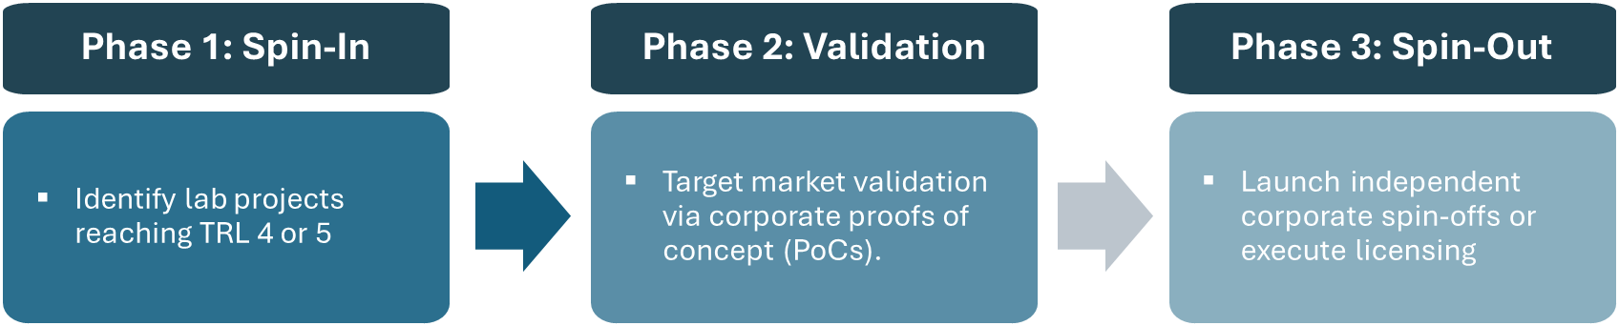

Dual-Use Technology Localization Focus
Given the geopolitically critical nature of space tracking, specific dual-use domains will be prioritized for domestic industrial localization:

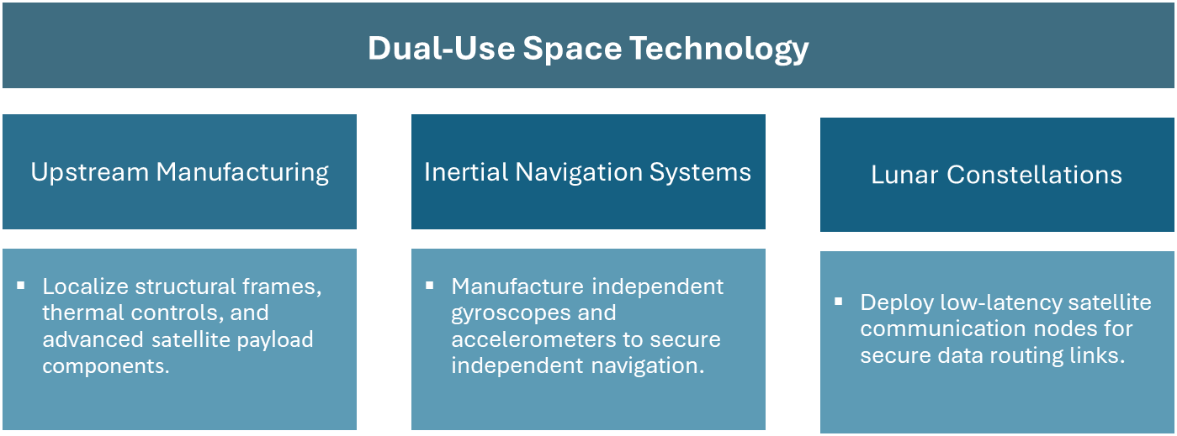

• Upstream Satellites
Localize structural frame manufacturing, multi-spectral camera lenses, thermal controls, and bus electronics within existing KACST manufacturing cleanrooms to drive down foreign supply dependence.
• Inertial Navigation Systems (INS)
Research and assemble specialized independent gyroscopes and accelerometers. This eliminates reliance on international navigation architectures, shielding strategic civil transport corridors from electronic spoofing or denial.
• Space Communications
Formulate native low-latency LEO communication routing payloads. This gives defense and intelligence agencies encrypted, un-jammable data capabilities without risking third-party intervention.

Operational Model: Public-Private Partnerships (PPP)
A shift from a pure cost-center state budget model to an asset-backed growth vehicle requires a flexible PPP framework that leverages private sector efficiency and capital.

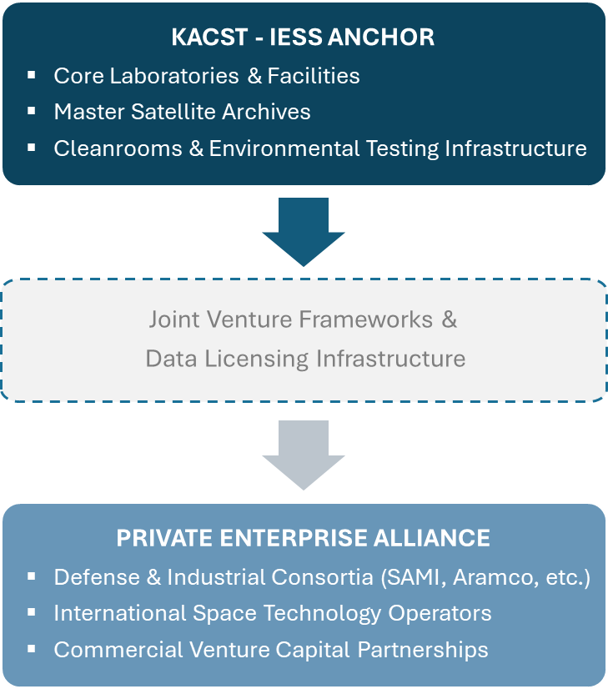

Strategic Co-Investment Mechanisms
• Co-Developed Shared Laboratories
Partner directly with local industrial champions (such as SAMI, Aramco, and STC) to build specialized technology centers within KACST facilities. Under this framework, KACST supplies the baseline cleanroom space, testing chambers, and research personnel, while corporate partners fund specialized manufacturing machinery, computing stacks, and commercial engineering salaries.
• Data-for-Equity Infrastructure Programs
Provide domestic and international space-tech startups with free processing time and raw satellite imagery access within the IESS National Remote Sensing Lab. In return, KACST secures a non-dilutive equity percentage in the startup, or options for exclusive domestic licensing rights to any software tools developed.
• Tiered Service Contracts
Offer guaranteed, long-term Service Level Agreements (SLAs) directly to corporate entities for operational site monitoring, resource extraction surveys, and regional infrastructure tracking. Private organizations fund the upfront deployment costs of dedicated micro-satellite constellations in exchange for guaranteed data access, transforming space R&D into a predictable, cash-flowing business model.

Forward Strategic Recommendations
To maximize the commercial viability and impact of this strategy, the board should integrate the following data tracks into the final proposal:
Comprehensive Workforce Capability Assessment
Action
Conduct a granular human resources capability audit to balance the existing technical footprint (e.g., mapping the current distribution of 19 PhDs and 297 engineers/technicians).
Objective
Identify specific skills gaps in AI algorithm design, non-terrestrial cloud engineering, and commercial space law, then resolve them through targeted global talent recruitment and exchange programs with corporate aerospace partners.
Global Market Pricing Framework
Action
Build a detailed market pricing and unit economics model for downstream geographic information systems (GIS) and value-added satellite data products.
Objective
Ensure the proposed commercial API endpoints are priced competitively against dominant global satellite data providers, while capturing higher regional margins by highlighting superior resolution, local compliance, and uncompromised national data independently.
Regulatory Sandbox for Non-Terrestrial Testing
Action
Partner with CST to establish a dedicated, permanent national regulatory testbed and sandbox for experimental satellite communications and high-frequency space observation systems within the Kingdom.
Objective
Attract international space technology pioneers by offering streamlined, rapid deployment authorizations and experimental spectrum access, positioning KACST as the primary destination for real-world space technology verification in the region.

Organizational Structure
The restructured hierarchy below bridges the gap between technical capability and market execution, ensuring every strategic objective is backed by a dedicated operational owner
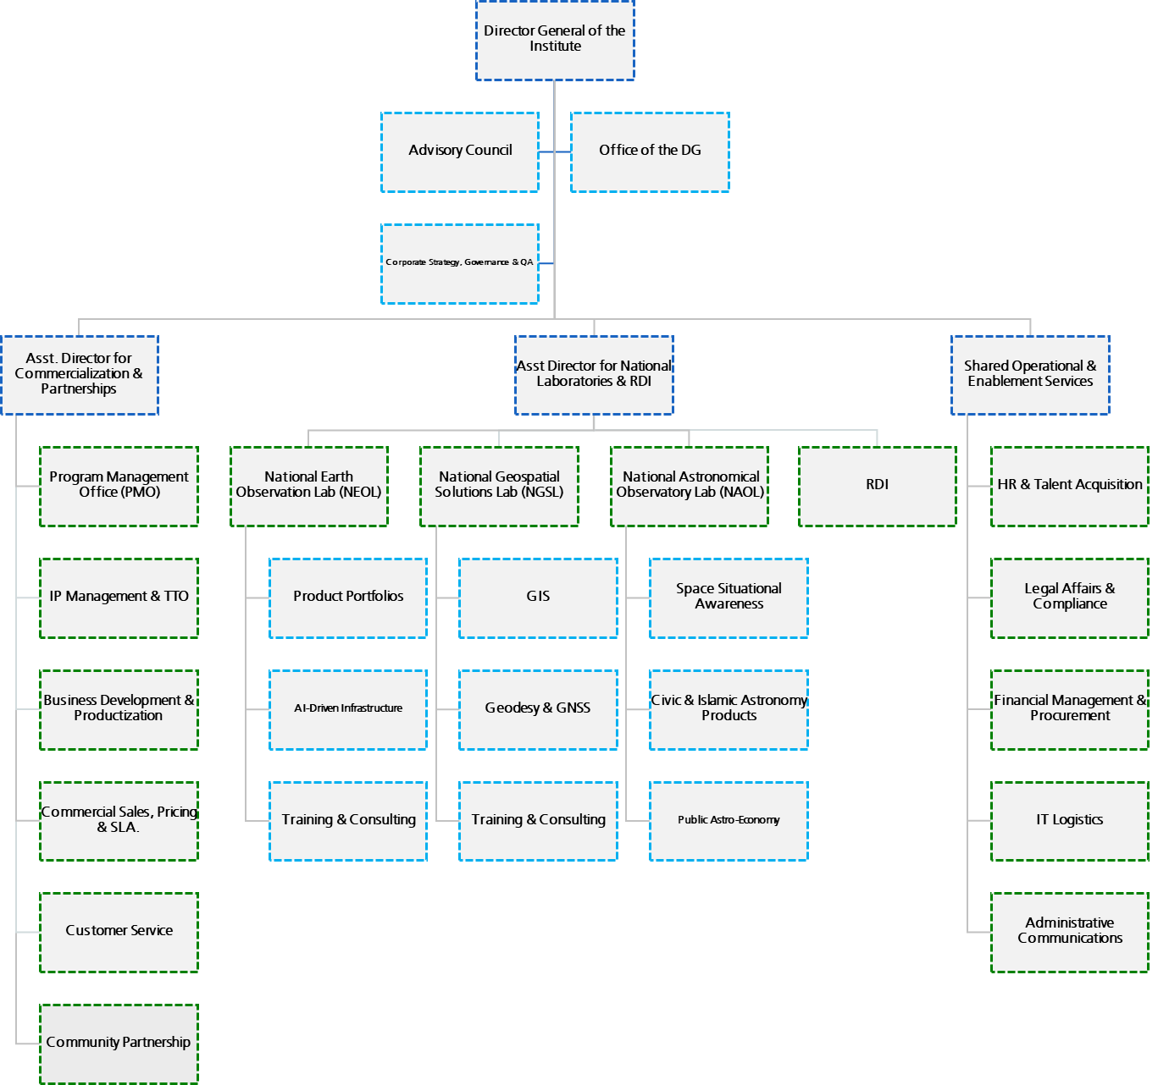

1. Leadership & Advisory Functions
1.1 Director General of the Institute
The top executive leader responsible for the overall strategic direction, decision-making, and management of the institute.
1.1.1 Advisory Council
A group of external or internal experts providing strategic guidance, feedback, and recommendations to the Director General.
1.1.2 Corporate Strategy, Governance & QA
Oversees long-term planning, organizational compliance, policies, and Quality Assurance (QA) standards.
1.1.3 Office of the DG
The administrative support unit handling scheduling, communications, and executive coordination for the Director General.

2A. Commercialization & Partnerships Division
2A.1 Asst. Director for Commercialization & Partnerships
The executive leader responsible for the Commercialization & Partnerships Division.
2A.1.1 Program Management Office (PMO)
Manages and governs specific high-priority programs and projects to ensure they are delivered on time and within budget.
2A.1.2 IP Management & TTO
Protects intellectual property (IP) and manages the Technology Transfer Office (TTO) to transition research into commercial products.
2A.1.3 Business Development & Productization
Manages Public-Private Partnerships (PPPs) and shared business Joint Venture with external commercial or government entities.
2A.1.4 Commercial Sales, Pricing & SLA
Handles product pricing, sales strategies, and the creation of Service Level Agreements (SLAs) for institutional offerings.
2A.1.5 Customer Service
Manages relationships, inquiries, support, and overall satisfaction for the institute's clients and users.
2A.1.6 Community Partnership
Cultivates ties with the local community, educational entities, and public audiences through outreach and collaborative initiatives.

2B National Laboratories & RDI Division
2B.1 Asst. Director for National Laboratories & RDI.
The executive leader responsible for the for National Laboratories & RDI.
2B.1.1 National Earth Observation Lab (NEOL)
Focuses on monitoring and analyzing Earth's physical, chemical, and biological systems via satellite and remote sensing data.
2B.1.1.1 Product Portfolios
Manages the specific commercial and data products generated by Earth observation activities.
2B.1.1.2 AI-Driven Infrastructure
Computer vision pipelines, deep learning foundations, and multi-modal data fusion
2B.1.1.3 Training & Consulting
Provides specialized educational programs and advisory services to external clients.
2B.1.2 National Geospatial Solutions Lab (NGSL)
Develops solutions based on geographic mapping, spatial data, and location intelligence.
2B.1.2.1 GIS
Focuses on Geographic Information Systems mapping, data capture, and spatial analysis.
2B.1.2.2 Geodesy & GNSS
Focuses on filed survey and Ground Control Points (GCPs) and coordinates utilizing Global Navigation Satellite Systems (like GPS).
2B.1.2.3 Training & Consulting
Offers mapping, GIS, and surveying training and consultancy to industry professionals.
2B1.3 National Astronomical Observatory Lab (NAOL)
Conducts space observations, telescope-based research, and astronomical tracking.
2B1.3.1 Space Situational Awareness
Tracks space debris, satellites, and near-Earth hazards to ensure safe space operations.
2B1.3.2 Civic & Islamic Astronomy Products
Develops tools and data for practical applications, such as lunar sighting calculations and prayer times
2B1.3.3 Public Astro-Economy
Promotes public awareness, tourism (Astrotourism), and economic ventures rooted in astronomy.
2B1.4 RDI
Core Research, Development, and Innovation department driving scientific breakthroughs and new methodologies.

2C Shared Operational & Enablement Services
2C.1 Shared Operational & Enablement Services Manager
The executive leader responsible for providing the infrastructure needed for the institute to run smoothly.
2C.1.1 HR & Talent Acquisition
Manages hiring, onboarding, employee relations, payroll, and professional development.
2C.1.2 Legal Affairs & Compliance
Handles contracts, provides legal counsel, and ensures operations conform to national and international regulations.
2C.1.3 Financial Management & Procurement
Oversees budgeting, accounting, asset management, and the purchasing of equipment and supplies.
2C.1.4 IT Logistics
Manages the technological infrastructure, network operations, hardware distribution, and digital security.
2C.1.5 Administrative Communications
Oversees internal documentation, incoming/outgoing official correspondence, and archival records.

